Reconstructing cellular traction from displacement data

- Open the Matlab environment and change to folder ‘TF_reconstruction_tools’

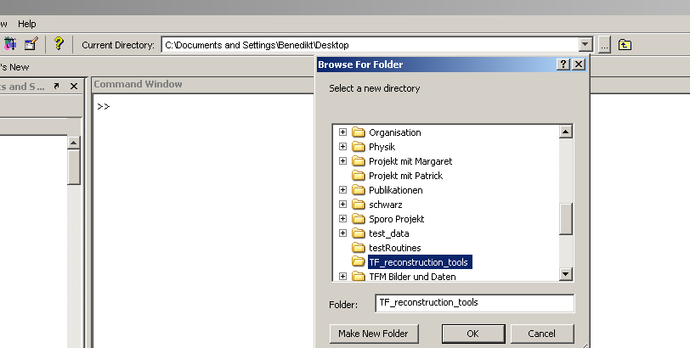

- Enter the command: ‘TF_reconstruction’

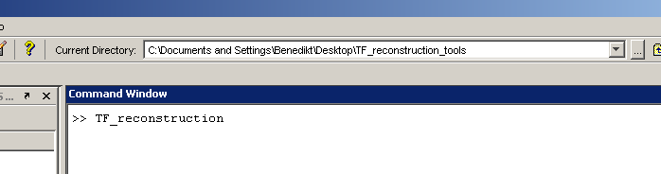
(You can really start the program from anywhere if you input the whole path)

- Feed some information to the program

Select the requested file and directories via ‘Browse’ buttons. Order your files in a systematic way and try not to change your name convention every day ☺

Of the fields in the lower panel Young’s modulus is most important. A comparison of your different data sets will only be possible if this value is given correctly.

The Poisson ratio can usually be left at its default value of 0.5.

The ratio of pixel to micrometer is determined by the camera system you are using. If you want to use the calculated strain energies, you should change this according to your setup.
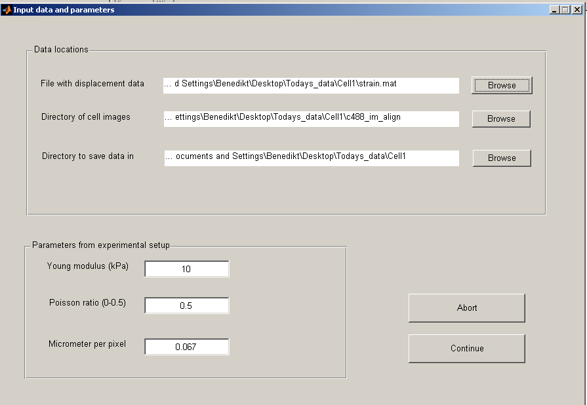

- Setting the smoothing parameter

The next mask should help you to find an appropriate smoothing parameter for the reconstructed traction. The choice of this parameter is in many ways important and you should have understood the following before selecting a level of smoothing:

- High smoothing will make your traction field ‘look better’, but it means to throw away much information about high frequency. This entails a suppressed traction magnitude.

- Low smoothing will usually allow the location of traction very well, but the vector field will look like a mess.

It is thus important to find a good tradeoff between these extremes. Start with the suggested value and vary it a little (by a factor of 10 or so), select an image and a data set and press ‘Preview’.
Do this until you think that the pattern given by the magnitude of traction fits well to the cell image and the traction vectors are ordered enough.

Note: if you want to compare the traction level between different cells, use (approximately) the same smoothing for all those data sets.

Examples:

Too low smoothing:
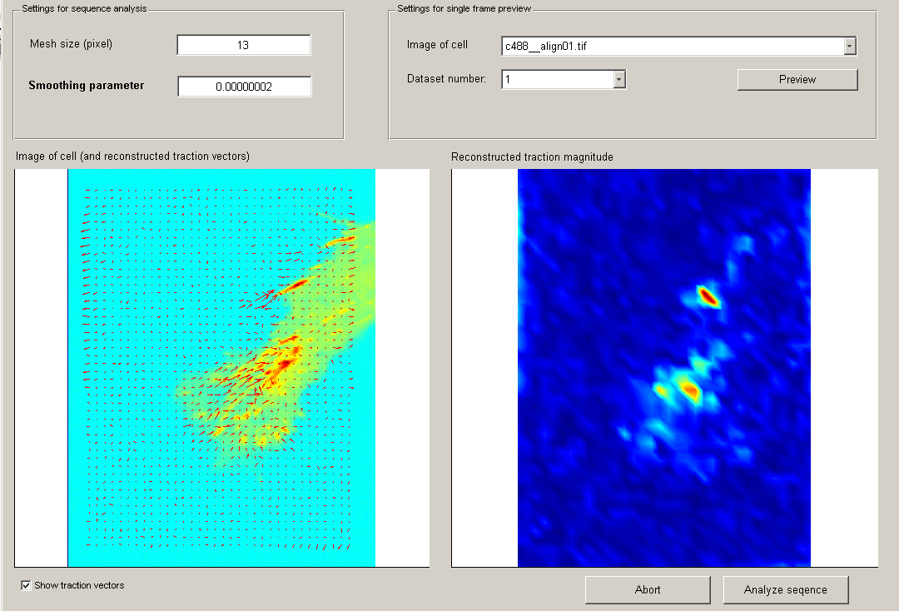

Too much smoothing:
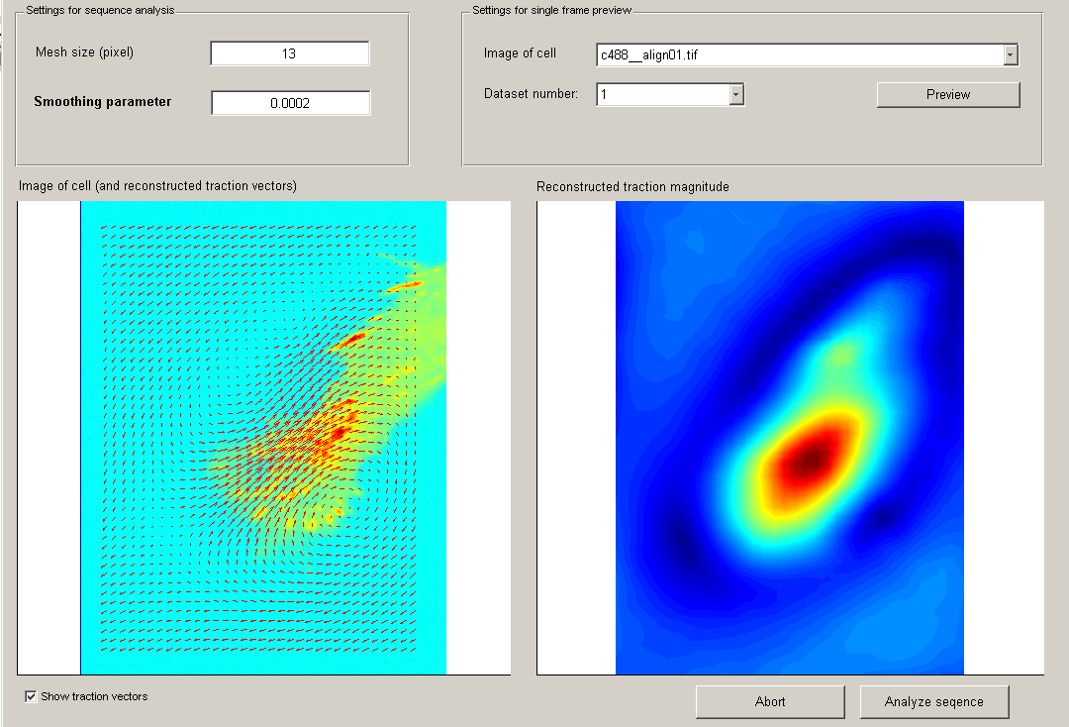

It is not recommended to change the mesh size very much. If you can like, you can change it by a few pixels and see whether you get a (visually) better resolution.

- Letting the program do its work

Once you have chosen a smoothing parameter, go ahead an press ‘Analyze sequence’.
The program will now calculate the traction fields and save them in a file called ‘Traction_reconstruction_dd-mm-jj.mat’ in the target directory you specified.
After that, it will terminate.

- The output

The output file can be opened in matlab by changing to the target directory and double clicking on the new file. It contains two structures:

- TFM_results
- TFM_settings

Important for you is probably only the first structure. Enter its name into the matlab command line to see what fields it contains:

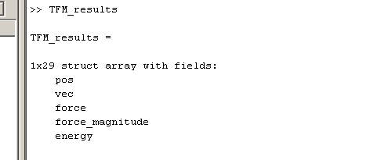

Contents

.pos contains the position (x,y) of the displacement field in .vec and at the same time the position of the traction field in .force.

.vec contains the displacement field interpolated to a regular grid

.force contains the traction vectors (x,y) in units of Pascal [N/m^2]

.force_magnitude is the 2-norm of above force vectors

.energy is the strain energy in the image given in pJoule (10^-12). This quantity should give you a feeling for ‘how strong’ the cell is.
The measure is however somewhat ambiguous because we use traction outside the boundary of the cell here and because sampling and aliasing effects are usually present.

Accessing the Vector fields (.pos, .vec, .force)

The organization of the vector fields is shown exemplary for .pos:

TFM_results(frame).pos(n, i)
Number of Location
Dataset number
X or Y component

To access for example the x- component of the 12-th traction vector in dataset (frame) 64 type: “TFM_results(64).force(12,1)”
To find where this traction vector is localized type (the operator “:” gives you all components at once): “TFM_results(64).pos(12,:)”

Accessing the scalar fields (.force_magnitude, .energy)

These fields are organized like above, only lacking the x,y components.

TFM_results(frame).force_magnitude(n)
TFM_results(frame).energy(n)

Examples:

